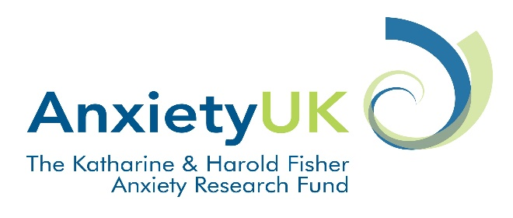

Katharine and Harold Fisher Anxiety Research Fund
Expression of Interest Form

Background/rationale for the project: (max 500 words)

Aim (max 200 words)

Method (max 1000 words)

Impact: What benefit will this research bring to Anxiety UK? Please refer to Anxiety UK’s strategic objectives - see: https://www.anxietyuk.org.uk/about-us/auk-mission-values-aims/ (300 words)

Details of client/service user involvement: (max 300 words)

Details of cost (up to £5,000 is available): (max 300 words)

Dissemination: (max 200 words)

Please submit this form by 31st March 2017 to:
Ms Nicky Lidbetter, Chief Executive: ceo@anxietyuk.org.uk

